**Assignment 7.1**

**Question 1:** Write a Mapreduce program to modify Sales of different TV Task 2 (refer session 5 assignment 2) to use a custom partitioner with 4 reducers. Make sure that all records whose company name starts with A-F (upper or lower case) should go to 1st reducer, those starting with G-L to 2nd reducer, those starting with M-R to 3rd reducer and others to 4th reducer.

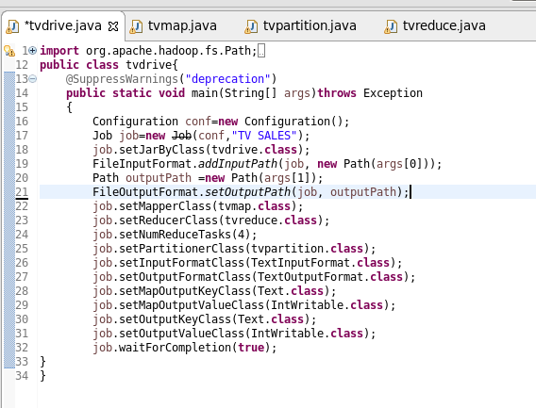

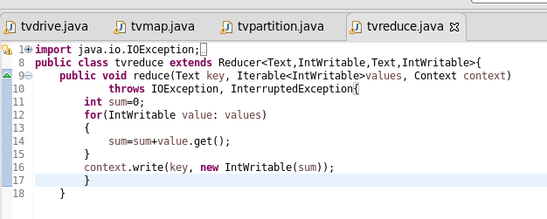

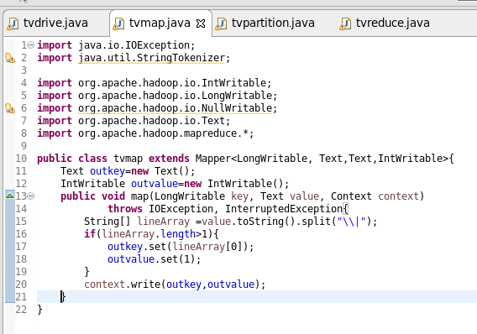

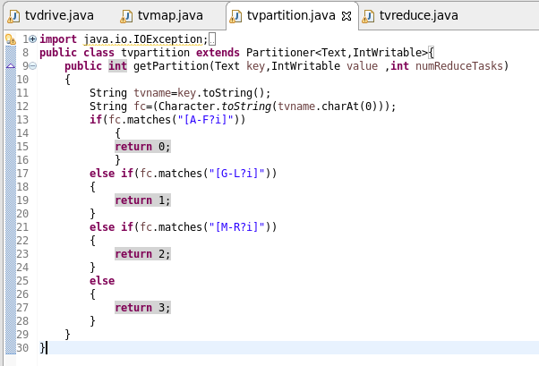

**Output:**   
  
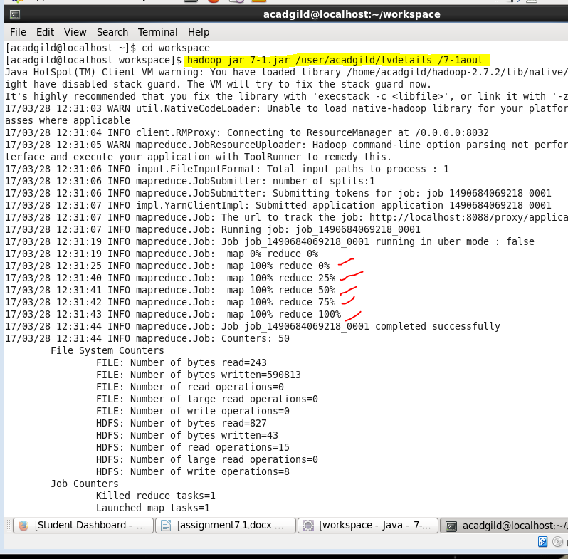

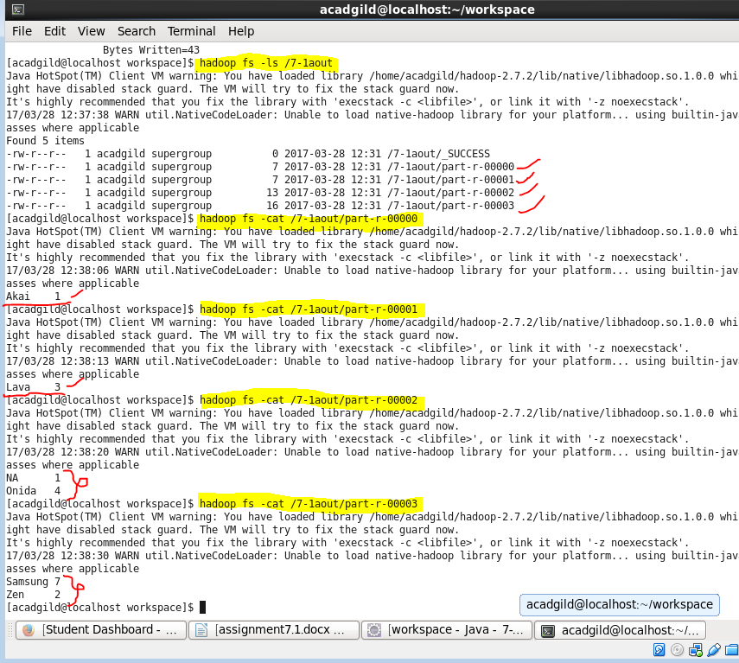

**Question 2:** Modify Sales of different TV Task 2 (refer session 5, assignment 2) to take advantage of Combiner.

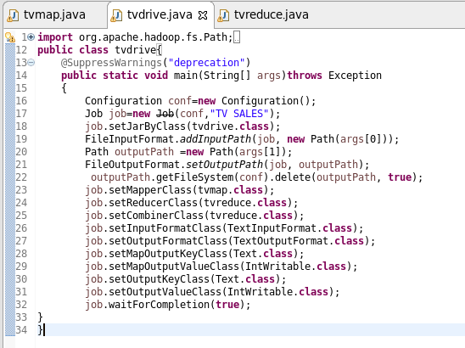

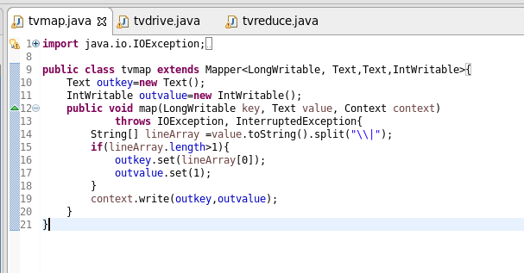

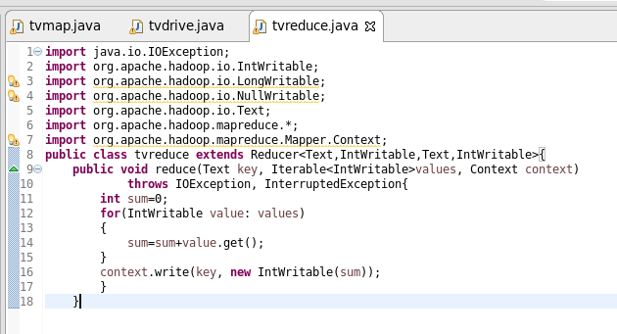

**Output:**

